Bluetooth HC-05 configuration in AT mode

Bluetooth when connected to the serial to usb converter enters into auto mode (led flashes in less than 1 sec). In this mode the Bluetooth can only be paired with the other devices. But to change the device name or the password the module should be in the AT mode. This can be made possible by powering the serial-usb converter and then powering the Bluetooth module. Follow the following steps to send the Bluetooth into AT mode.

Make the connections from serial-usb converter to Bluetooth module

|  |
| --- |
| Serial-usb Bluetooth module |
| Gnd Gnd |
| Tx Rx |
| 5V 5V |
| Rx Tx |
| 3.3V Pin-34 |

Bluetooth module

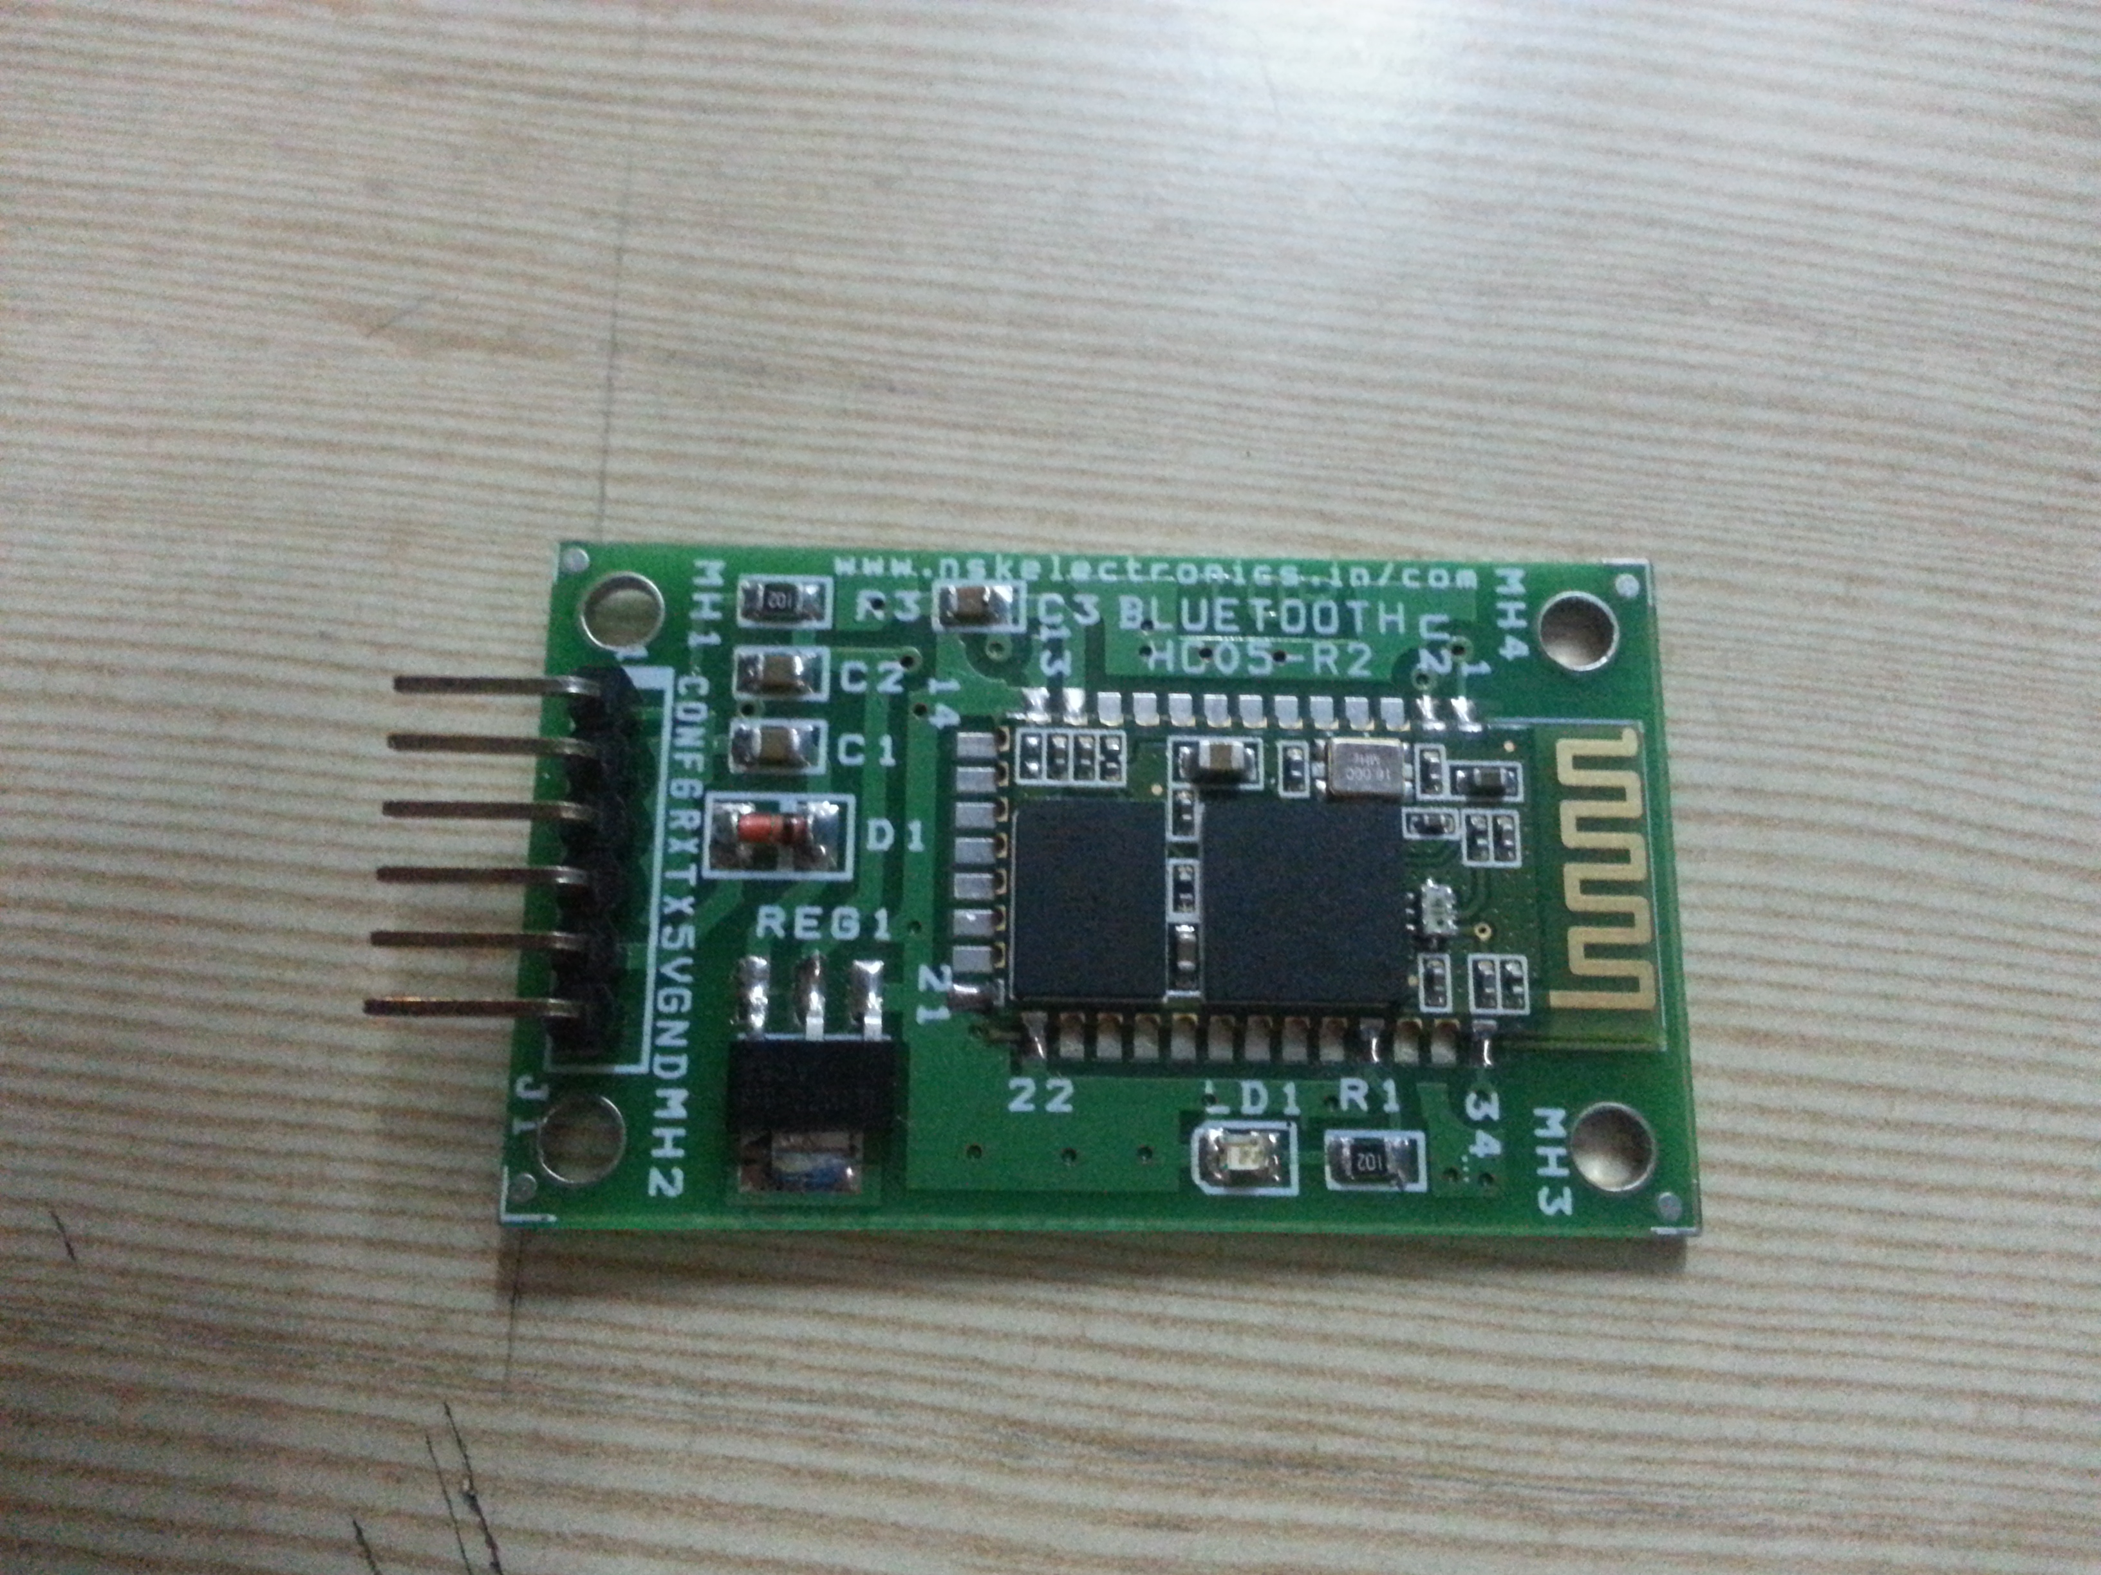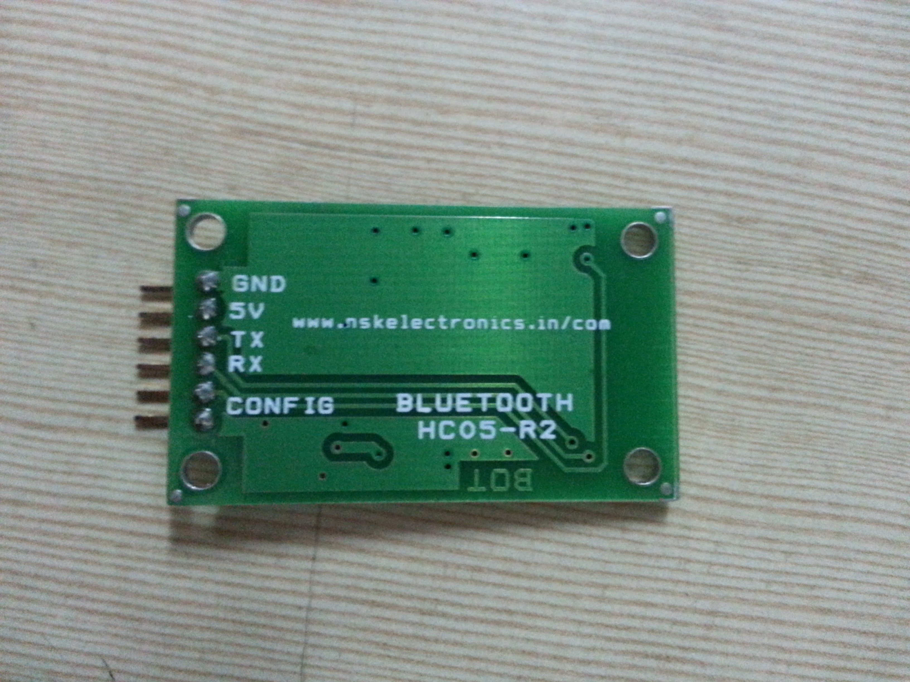

Serial-usb converter

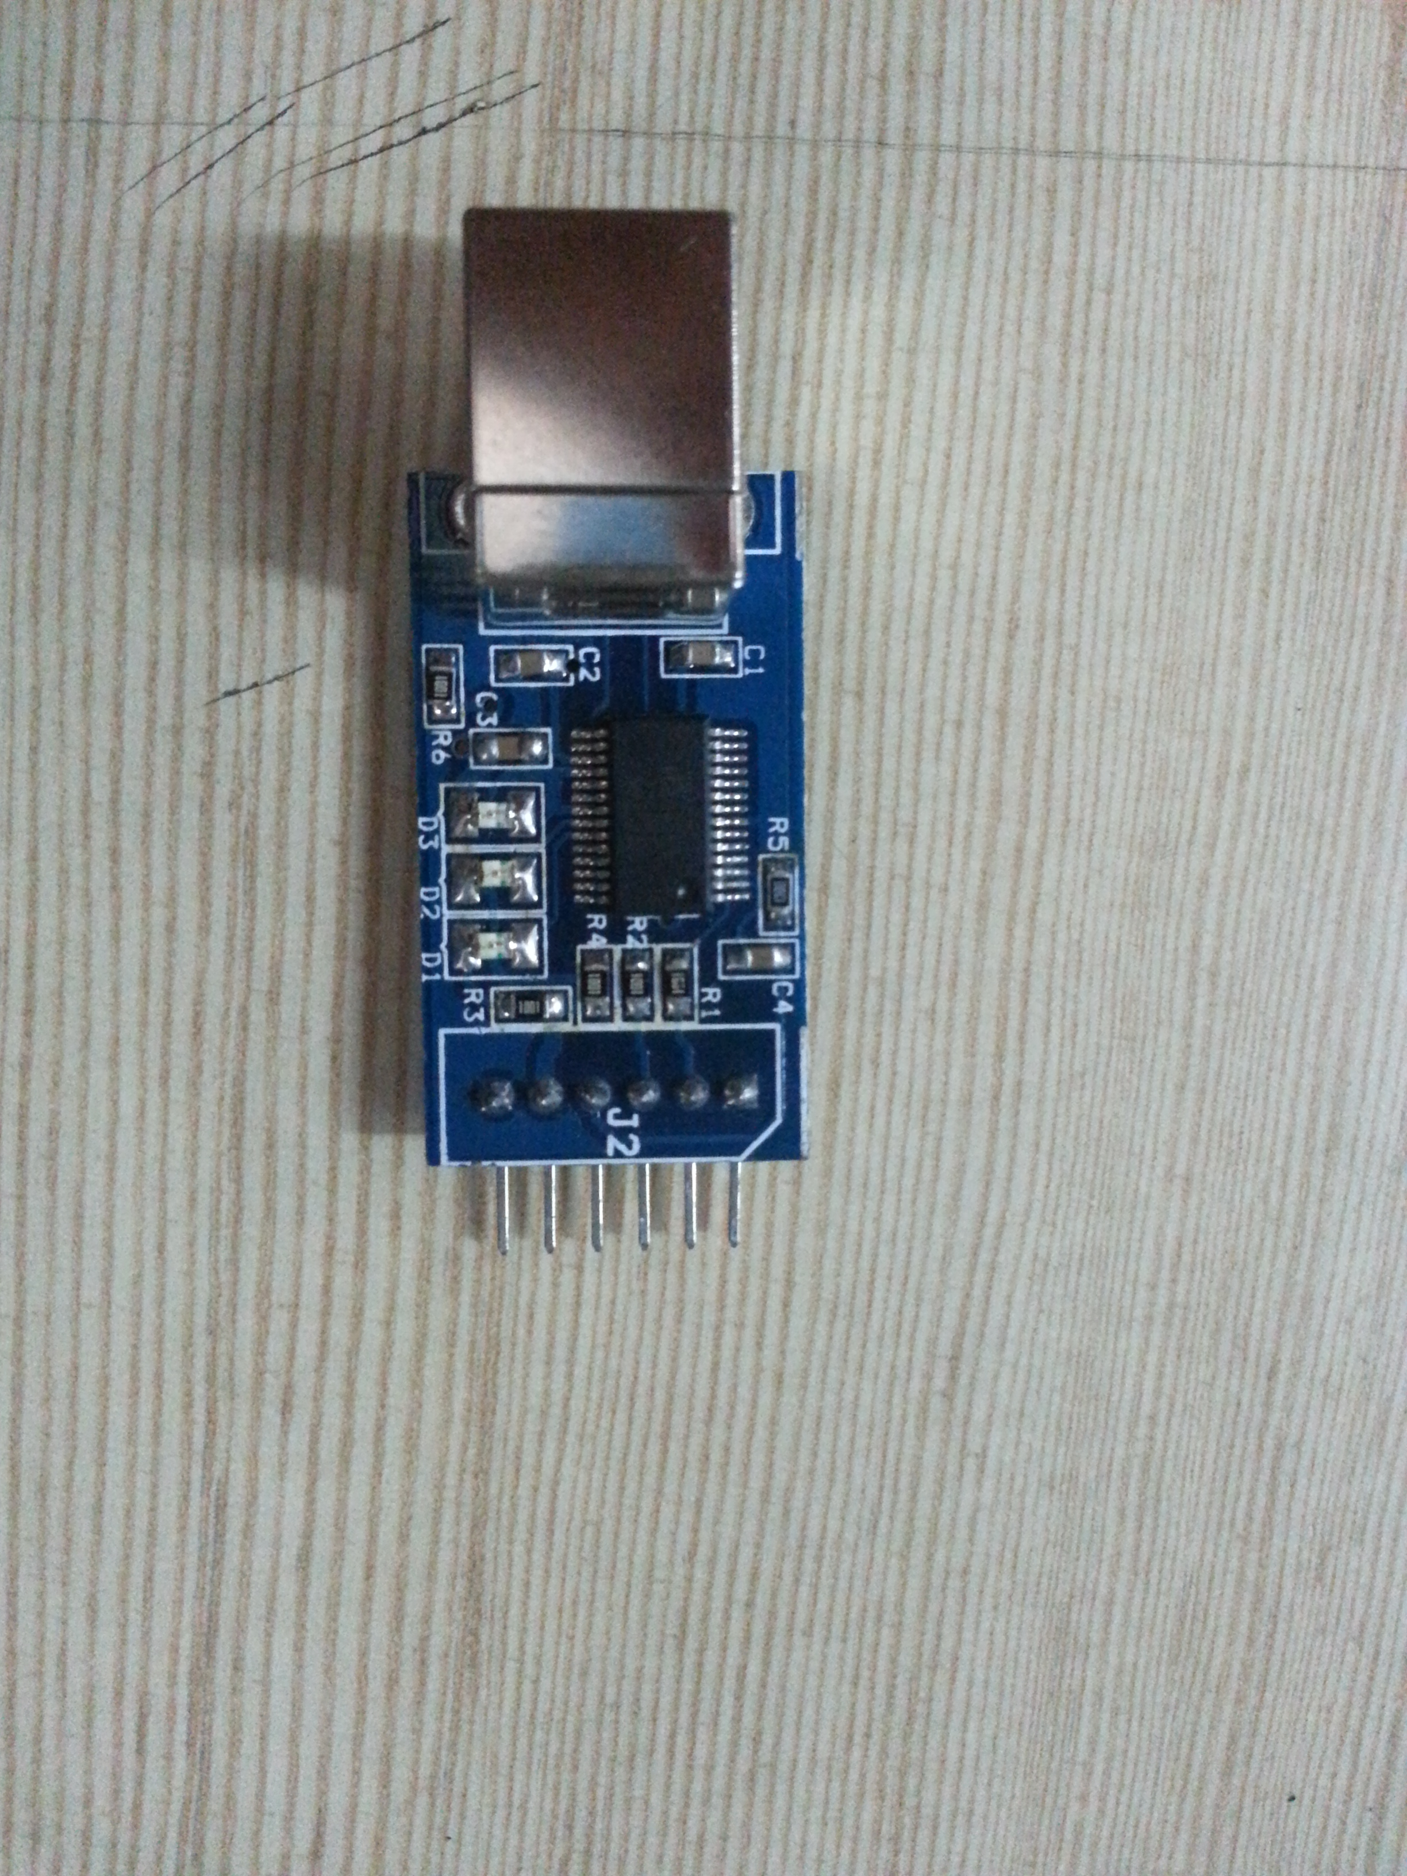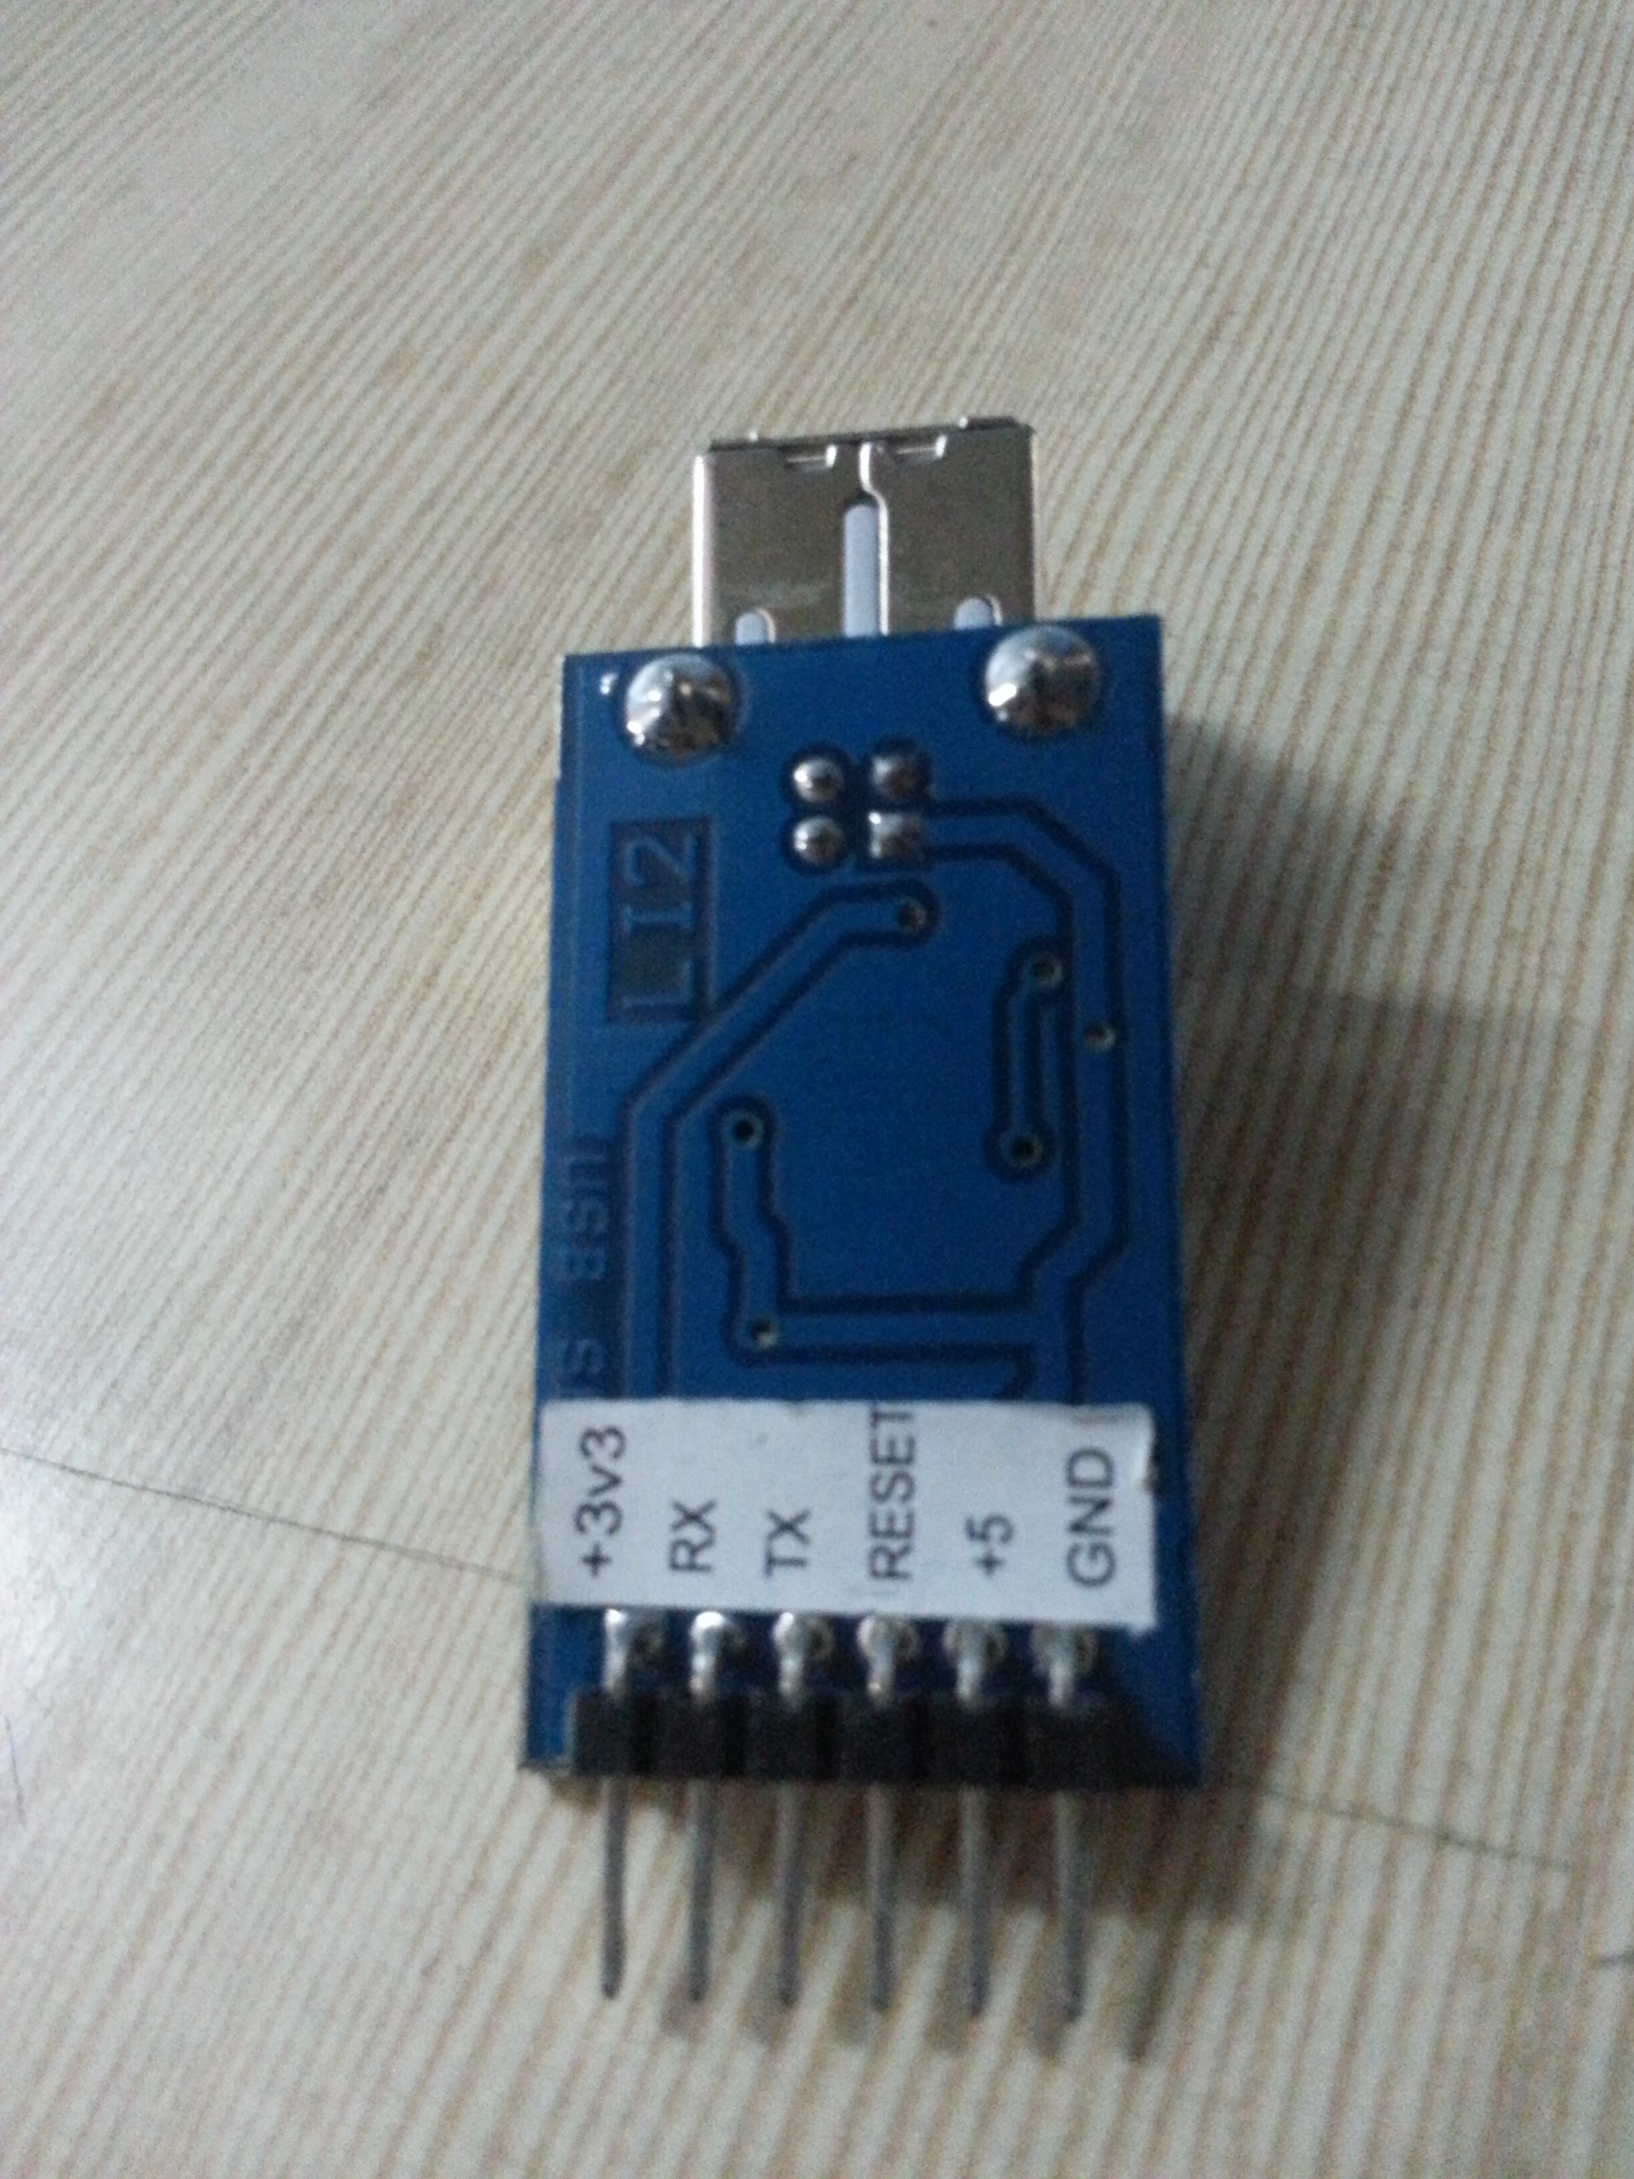

Connections

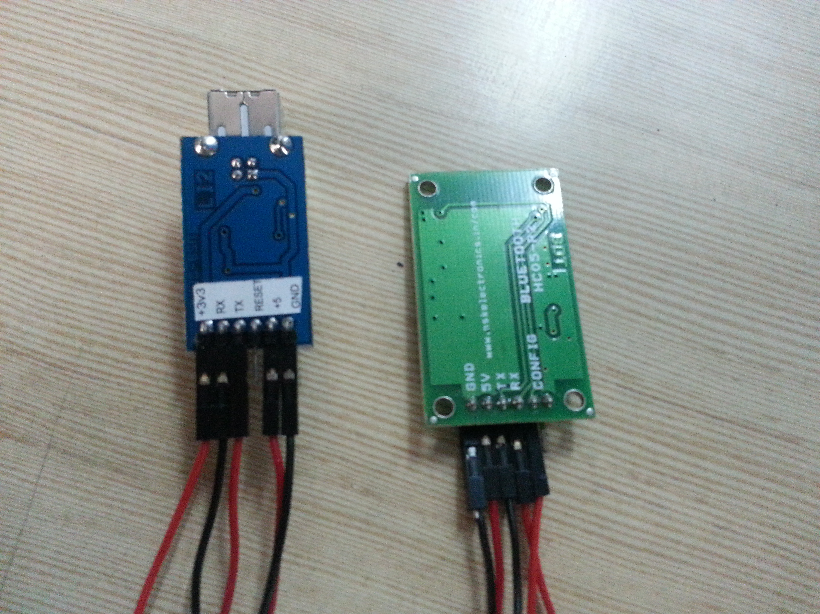

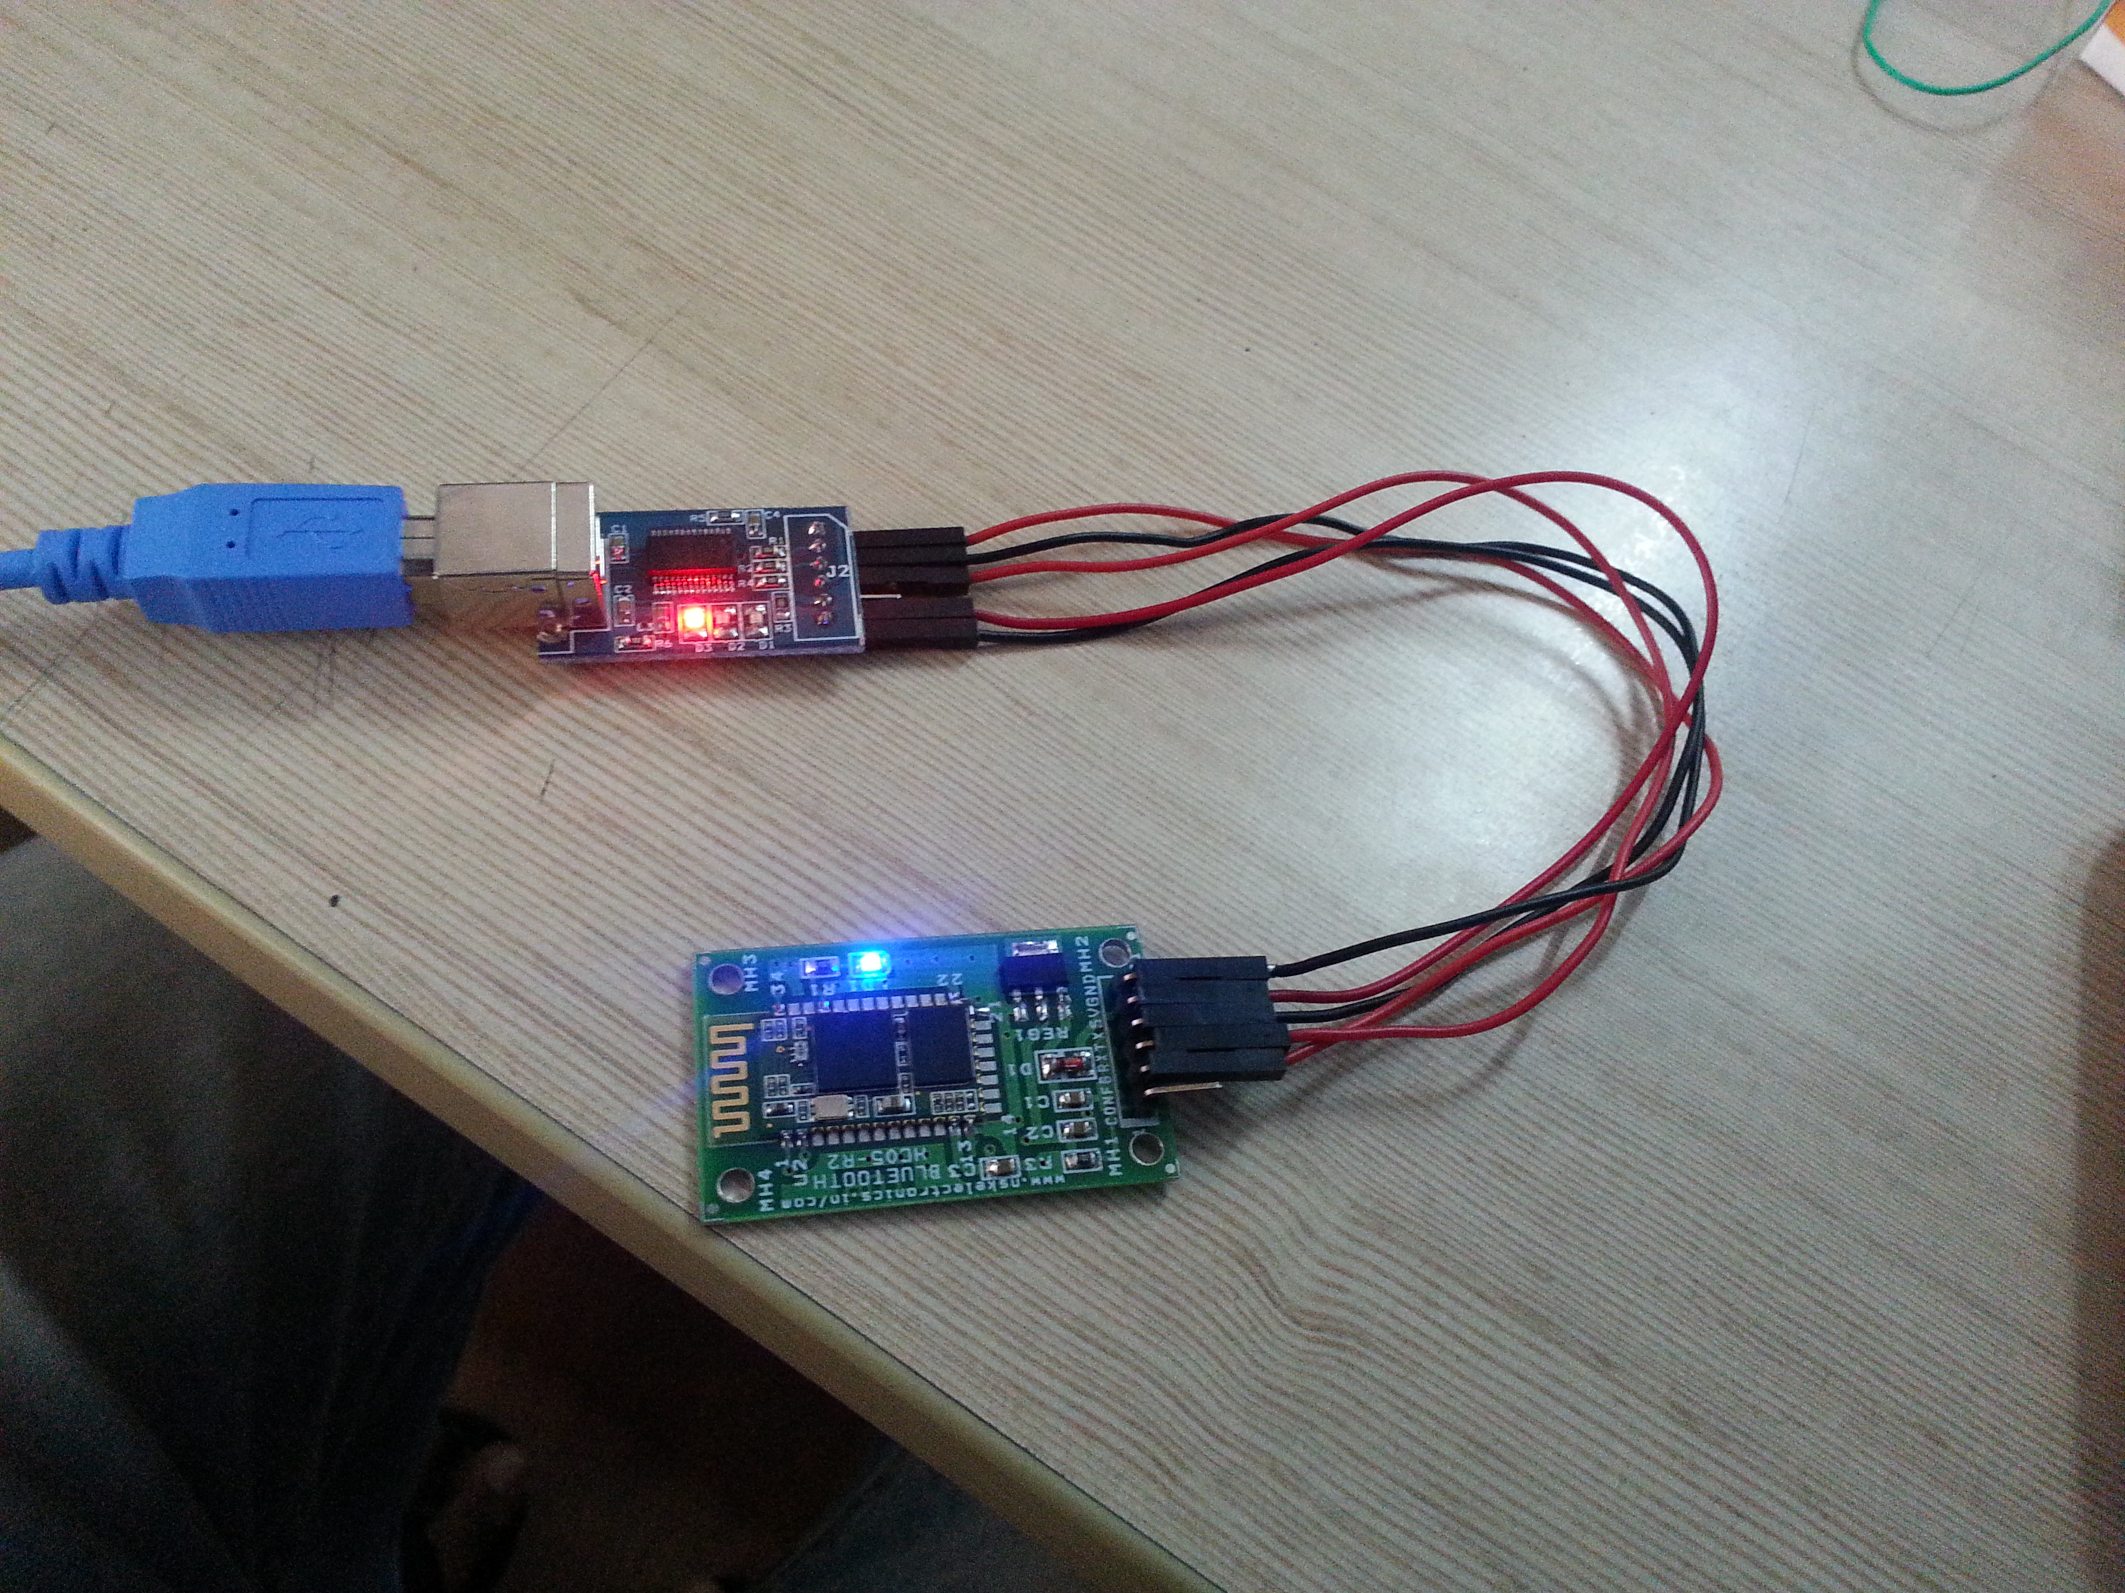

After the following connections, power up the connection by connecting the usb to computer.

Now remove the 5V pin of the Bluetooth module and connect it back to the same pin after a while. Now the led of the Bluetooth module starts blinking. It will be a 2-sec blink. Now the Bluetooth module is in AT mode. The order of the events mentioned above is important. You may not set the Bluetooth module if these steps are not followed in same order.

Download any terminal software to send the AT commands. Here, a terminal software called Hyper Terminal is used. Follow the steps given below.

Open the terminal. A window pops out which says connection description.

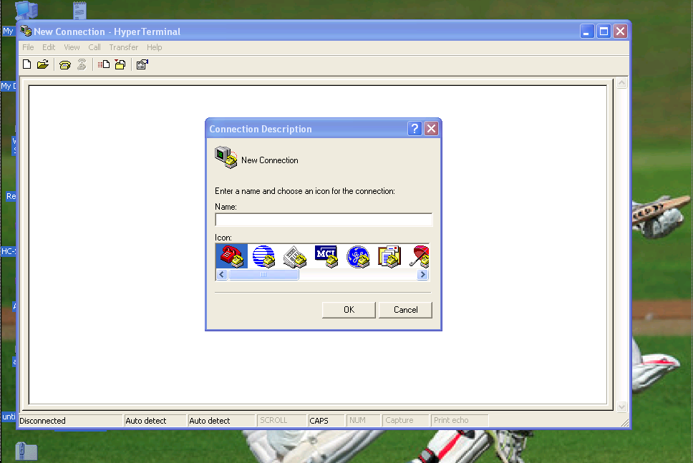

Give a arbitrary name to save and say OK.

If location information is asked just cancel the window.

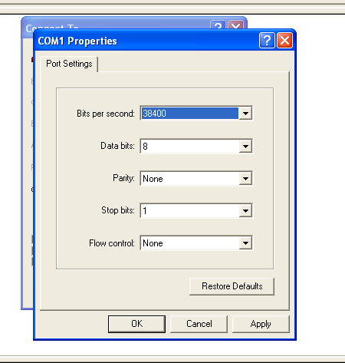After this another window pops out saying “Connect to”. There seclect the usb port to which the module is connected. To know this, right click on my computer, manage, device manager, ports will show you to which the module is connected. Select the right port and click configure which can be found right below the dialogue box. Set baud rate to 38400 which is the default baud rate of the Bluetooth module. Data bits as 8, stop bits to 1 and parity and flow control to none. Say OK.

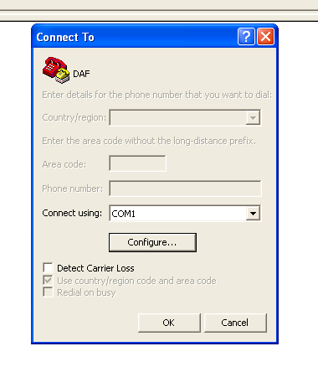

Now you can see a blank terminal window. Click on files in the tool bar and go to properties.

Another window pops out. Choose settings in the tool bar. Make the following changes.

Change emulation to “ANSI”

Then Click “ASCII SETUP”, enable “echo typed characters locally” in sending section and “append line feeds to incoming line ends” in the receving section. Press OK.

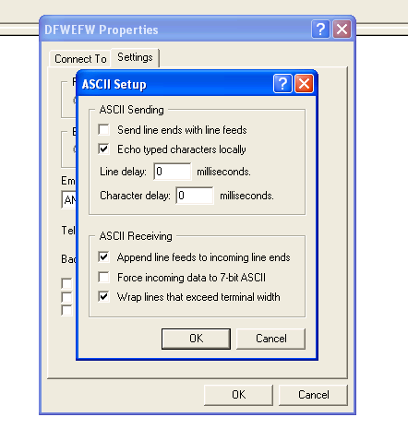

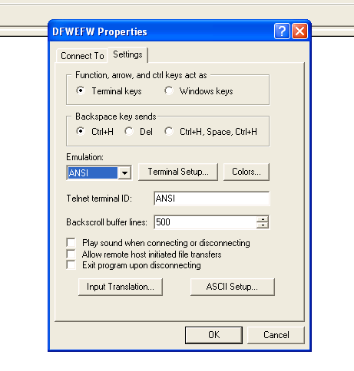

Now commands can be sent into the module by typing in the terminal.

To check type “AT” and press Enter

You must see a “OK” replied by the module.

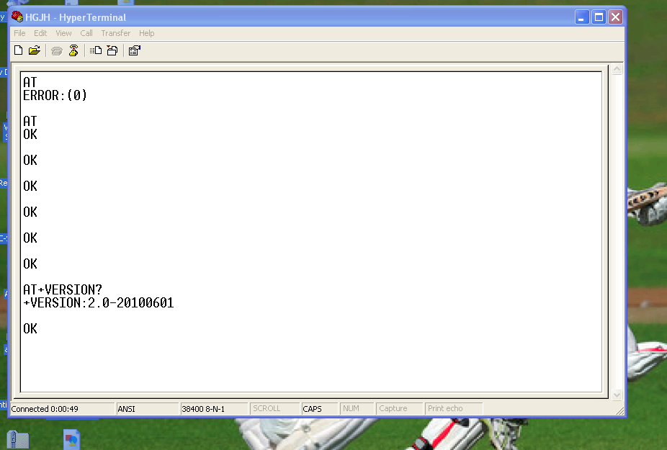

Given below are the commands

/*(remove double quotes from AT command)

To return HC-05 to mfg. default settings: "AT+ORGL"

To get version of your HC-05 enter: "AT+VERSION?"

To change device name from the default HC-05 to let's say MYBLUE enter: "AT+NAME=MYBLUE"

To change default security code from 1234 to 2987 enter: "AT+PSWD=2987"

To change HC-05 baud rate from default 9600 to 115200, 1 stop bit, 0 parity enter: "AT+UART=115200,1,0" */

Processing and debugging errors

1. How to confirm that Bluetooth has entered into AT mode?

Sol:

After powering the serial-usb converter by connecting to the computer remove the 5V pin from the Bluetooth module and connect it back. Make sure that the pin 34 is connected to the 3.3V pin. When the Bluetooth module is powered the mode to which it has entered is indicated by the fashion in which the led of the module blinks. If you have a 2 sec blink then it’s the AT mode. The other mode is the auto mode. The led blinks with a faster rate.

2. Why am I not getting OK from Bluetooth??

Sol:

This might be due to several reasons. Any mistake in any step will cause this. Set proper baud rate-38400. Specify the port correctly. (Eg. Com9). Make sure that the commands have proper syntax. Go through all the configuration settings thoroughly. Make sure that the module is in AT mode.

3. Why are the characters not appearing in the terminal when typed?

Sol:

Don’t forget to enable the ASCII setup in configuration.